***David Stern***

***DATA 621: Business Analytics and Data Mining***

***MSc Data Analytics, CUNY SPS***

***Data Exploration***

Our dataset consists of 16 variables detailing the performance of professional baseball teams. Each record represents a team’s performance for a given season from 1871-2006. The variables include offensive and defensive metrics such as base hits by batters, fielding errors, and strikeouts by pitchers that we will use to predict the team’s wins for the season. The data is split into training and evaluation set with the total wins for the season removed from the latter. There are 2271 records in the training set and 259 records in the evaluation set.

Here a quick overview of the variables in the dataset:

|  |  |  |
| --- | --- | --- |
| ***Variable*** | ***Abbrev.*** | ***Description*** |
| TARGET_WINS | W | Number of wins |
| TEAM_BATTING_H | B_H | Base Hits by batters (1B,2B,3B,HR) |
| TEAM_BATTING_2B | B_2B | Doubles by batters (2B) |
| TEAM_BATTING_3B | B_3B | Triples by batters (3B) |
| TEAM_BATTING_HR | B_HR | Homeruns by batters (4B) |
| TEAM_BATTING_BB | B_BB | Walks by batters |
| TEAM_BATTING_HBP | B_HBP | Batters hit by pitch |
| TEAM_BATTING_SO | B_SO | Strikeouts by batters |
| TEAM_BASERUN_SB | B_SB | Stolen bases |
| TEAM_BASERUN_CS | B_CS | Caught stealing |
| TEAM_FIELDING_E | F_E | Errors |
| TEAM_FIELDING_DP | F_DP | Double Plays |
| TEAM_PITCHING_BB | P_BB | Walks allowed |
| TEAM_PITCHING_H | P_H | Hits Allowed |
| TEAM_PITCHING_HR | P_HR | Homeruns Allowed |
| TEAM_PITCHING_SO | P_SO | Strikeouts by pitcher |

We will first look at the distribution of the variables by examining the histograms of each one.

***Histograms of Variables in Training Set***

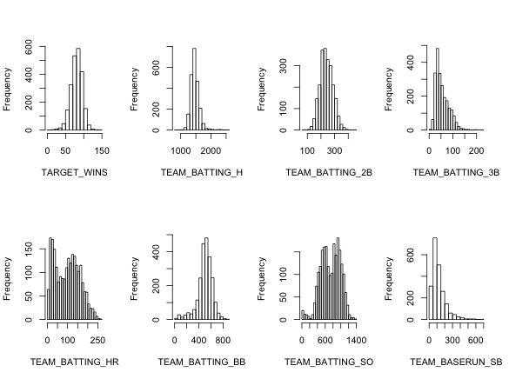

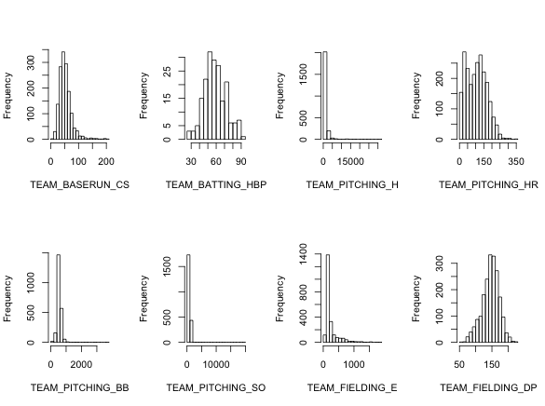

We see above that the variables do vary somewhat in their distributions. The very first plot shows that our response variable, wins, seems normally distributed around it’s mean – 80.8 – and is not skewed. It is interesting to note that the wins distribution proves Tommy LaSorda’s axiom incorrect. Not all teams win 60 games and lose 60 games – about 15% of seasons actually fall outside the range of 60-102 wins.

Some of the variables appear normally distributed with a small amount of skew: triples by batter, walks by batter, and caught stealing. A few others - strikeouts by batter, homeruns allowed, homeruns by batter – appear bimodal. We should also note that a few of the variables seem to be distorted by unusually highly values so we will take a closer look at the distributions for fielding errors, and hits, walks, and strikeouts allowed.

***Summary Statistics Table***



This table demonstrates that the four variables under suspicion are in fact distorted by improbably high values. For fielding errors, it seems improbable that a team could average over 10 errors per game over the course of a season, but the distribution shows that this the maximum is not an outlier, but the right tail of exponential decay. The shape of these distributions will be important later on when deciding how to impute data for variables with missing values.

***Data Preparation***

While examining the outliers for strikeouts, I identified five records – rows 1, 282, 1342, 1826, 2136 - with more than 2500 strikeouts by pitcher. Some of the strikeout counts were actually impossible to achieve even if a team struck out every batter for every out over the course of a season. I decided to delete these records from our training data. They also contained improbably high values for walks allowed, hits allowed, and fielding errors allowed, so these were very likely data entry errors, or incorrectly scaled for those seasons with fewer than 162 games. Since we will want to choose the best method for imputing the missing values for each variable, I plotted strikeouts by pitcher again without the extreme outliers. The distribution seems much more normally distributed around the mean of 799.

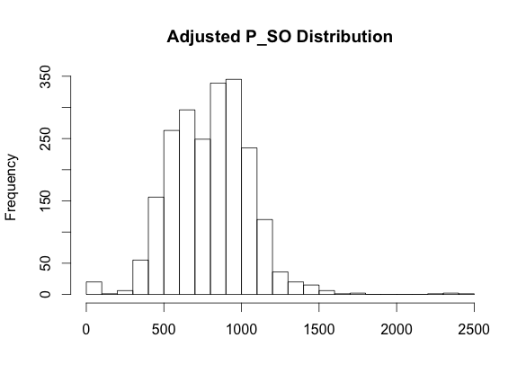

Next I looked into the six variables with missing values. These variables and the proportion of the data that is missing for each is:

|  |  |
| --- | --- |
| ***Predictor*** | ***Pct. NA*** |
| TEAM_BATTING_SO | 4.5% |
| TEAM_BATTING_SB | 5.8% |
| TEAM_BASERUN_CS | 33.9% |
| TEAM_BATTING_HBP | 91.6% |
| TEAM_PITCHING_S0 | 4.5% |
| TEAM_FIELDING_DP | 12.6% |

Here we see that some variables are missing much more data than others. We will explore the effectiveness of imputing missing values with some of the variables with a smaller proportion of data missing: strikeouts by batters, stolen bases, pitching strikeouts, and perhaps also fielding double plays. The percentage of those missing values for caught stealing and batters hit by pitch, seem very high and we may be better off deleting these variables altogether. If we perform exploratory data analysis in R without removing missing values, our linear regression function *lm* and correlation matrix *cor(data, use=na.or.complete)* will not include any records that have one or more missing values. This means that at least 91.6% of our training data will be discarded. To determine how best to proceed, I eliminated the batters hit by pitch variable from the dataset and created a correlation matrix of the remaining variables. Although records with missing values were excluded from the correlation data, we know from the percentages from the table above that the correlations will still be calculated from at least 40% of our training data. We should however be careful in drawing conclusions from the correlation matrix. We will only use it to identify possible collinearities.



The correlation matrix shows us that there are a number of moderate correlations between the variables, $0.3≤\left|x\right|≤0.5$ (in light red for negative, light blue for positive) and strong correlations $\left|x\right| ≥0.5$ (dark red for negative, dark blue for positive). This gives us an early hint that there we will very likely see the effect of multicollinearity in a full multiple linear regression fit, but that we might also be able to predict the missing values for some predictor variables by performing linear regression on some subset of the other predictors.

Before I started fitting models, I fit each of the predictor variables against our predictor variable, target wins, to make sure that the errors were normally distributed. They are each normally distributed around a mean of 0. I also examined scatterplots of the squared residuals for each of the simple regression models and did not identify any pattern in the size of the residuals for any predictor. Each appears to be homoscedastic.

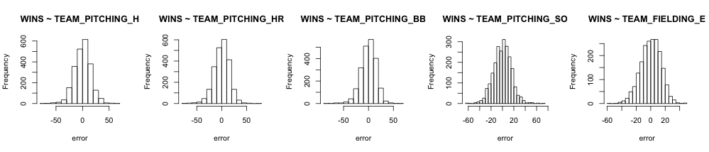

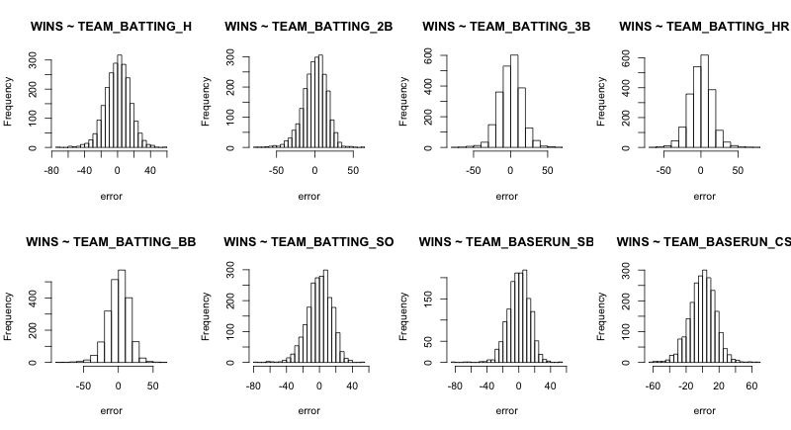

***Building Models***

Before dealing with the missing values in the training data, I wanted to build a model that used only the records with data for each variable.

First, I fit each of the predictor variables individually to the response variable, wins, and found that the highest r-squared value was 0.15 for hits by batters (B_H). The p-value for the model was very significant with a value of 2.2e-16.

***Model 1***

Next, I built the first multiple linear regression model by fitting all of the variables and working backwards, updating the model by subtracting one variable in order of descending p-value. After subtracting, in order, walks allowed, homeruns allowed, and strikeouts by batter, the p-values for model and for the individual predictors all dropped below 0.05. The goodness of fit measures and coefficients are:

|  |  |  |  |
| --- | --- | --- | --- |
| ***Model p-value*** | ***f-stat*** | ***R-squared*** | ***RSE*** |
| <2.2e-16 | 104.6 on 11 and 1474 df | 0.4384 | 9.548 | |

|  |  |  |  |  |  |  |  |  |  |  |  |
| --- | --- | --- | --- | --- | --- | --- | --- | --- | --- | --- | --- |
| ***Intercept*** | ***B_H*** | ***B_2B*** | ***B_3B*** | ***B_HR*** | ***B_BB*** | ***B_SB*** | ***B_CS*** | ***P_H*** | ***P_SO*** | ***F_E*** | ***F_DP*** |
| 58.4 | 0.03 | -0.07 | 0.16 | 0.10 | 0.04 | 0.04 | 0.05 | 0.01 | -0.02 | -0.16 | -0.11 |

The R-squared value shows us that the model explains just about 44% of the variation in the model. Some of the coefficients are counterintuitive. We would assume that strikeouts by pitcher (P_SO), fielder double plays (F_DP), and doubles by batter (B_2B) to have a positive effect on wins, but the coefficients are negative. We would also expect batter caught stealing (B_CS), hits allowed (P_H) to be negative, but the coefficients are positive. We can certainly improve on this model.

***Model 2***

We can improve this model by imputing the missing values. Since the linear regression function does not include records with NA values, 785 records (or 34.5%) of our training data set is essentially discarded. Based on the shape of the distributions, I imputed the missing values for strikeouts by batter (B_S) and stolen bases (B_SO) with the median values for each variable. I imputed the missing values for the more normally distributed variables – caught stealing (B_CS), strikeouts by pitcher (P_SO) and double plays fielded (F_DP) – with the mean for each variable. I then fit the full model and again worked backwards. After subtracting, in order, homeruns allowed, hits allowed, and caught stealing, the p-values for model and for the individual predictors all dropped below 0.05. The goodness of fit measures and coefficients are:

|  |  |  |  |
| --- | --- | --- | --- |
| ***Model p-value*** | ***f-stat*** | ***R-squared*** | ***RSE*** |
| <2.2e-16 | 97.04 on 11 and 2259 df | 0.3209 | 12.96 | |

|  |  |  |  |  |  |  |  |  |  |  |  |
| --- | --- | --- | --- | --- | --- | --- | --- | --- | --- | --- | --- |
| ***Intercept*** | ***B_H*** | ***B_2B*** | ***B_3B*** | ***B_HR*** | ***B_BB*** | ***B_SO*** | ***B_SB*** | ***P_BB*** | ***P_SO*** | ***F_E*** | ***F_DP*** |
| 22.64 | 0.04 | -0.03 | 0.07 | 0.07 | 0.03 | -0.02 | 0.03 | -0.01 | 0.01 | -0.02 | -0.12 |

With a much lower r-squared value, this model does not seem as good a fit as the previous one. Aside from the intercept, the magnitude of the coefficients did not change drastically. The only variable in both of the models that changes sign is strikeouts by pitcher (P_SO). This is a good sign, although it has a relatively small effect in the model and the difference in coefficients is only 0.03.

***Model 3***

For my third model, I hoped to see if I could improve the model by also imputing the zero values for each of the variables. Given that the non-occurrence of any of the events described by the variables during a baseball season is extremely improbable, we might want to treat these as missing values: zeroes entered in data where none was available. I imputed the zero values for each of the variables with the mean value and worked backwards from the full model. After the p-values for each of the predictors dropped below 0.05, the measures and coefficients are:

|  |  |  |  |
| --- | --- | --- | --- |
| ***Model p-value*** | ***f-stat*** | ***R-squared*** | ***RSE*** |
| <2.2e-16 | 87.59 on 12 and 2258 df | 0.3176 | 13 | |

|  |  |  |  |  |  |  |  |  |  |  |  |  |
| --- | --- | --- | --- | --- | --- | --- | --- | --- | --- | --- | --- | --- |
| ***Intercept*** | ***B_H*** | ***B_2B*** | ***B_3B*** | ***P_HR*** | ***B_BB*** | ***B_SO*** | ***B_SB*** | ***P_BB*** | ***P_SO*** | ***F_E*** | ***F_DP*** | ***P_H*** |
| 9.07 | 0.06 | -0.03 | 0.07 | 0.05 | 0.03 | -0.01 | 0.03 | -0.01 | 0.01 | -0.02 | -0.11 | 0 |

Based on the R-squared value, this model seems to be a slightly worse fit than the previous. The coefficients are virtually the same – for those that did change, the difference is negligible.

***Select Models***

Of the three multiple linear regression models, I think our first model provided the best fit to our data. Although the model was trained on a much smaller portion of the data, it provides the highest R-squared value and lowest residual standard error (RSE) than the two models with the missing values and zeroes imputed with mean and median values. Since we are fitting many variables, we should use the RSE as the goodness of fit measure, since the R-squared value will increase for each predictor that we add. This was demonstrated in the backwards selection process as the R-squared value dropped - sometimes by very small numbers - for each predictor that was removed from the model. The variance inflation factors (VIF) for the predictors in this model also returned relatively low values compared to the other models. Each of the VIFs is below 10 so we can conclude that there is less effect of multicollinearity in this model.

***Model 1 VIF***

|  |  |  |  |  |  |  |  |  |  |  |
| --- | --- | --- | --- | --- | --- | --- | --- | --- | --- | --- |
| ***B_H*** | ***B_2B*** | ***B_3B*** | ***B_HR*** | ***B_BB*** | ***B_SB*** | ***B_CS*** | ***P_H*** | ***P_SO*** | ***F_E*** | ***F_DP*** |
| 6.04 | 2.48 | 2.78 | 3.43 | 1.12 | 2.41 | 2.82 | 2.71 | 3.91 | 2.43 | 1.16 |

Finally, I used Bayesian information criterion (BIC) to determine the best number of predictors to use in the subset. In the plot below we see that the BIC is minimized between 9 and 11 predictors, so our model is within the proper range.

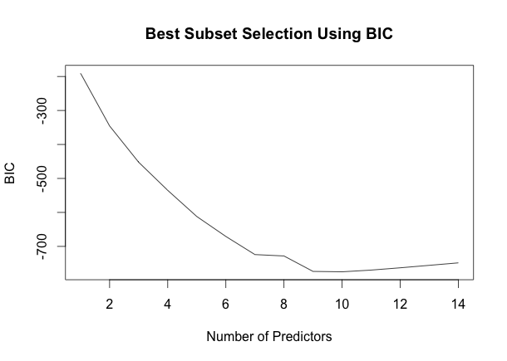

Although the signs for some of the coefficients for our first model seem counterintuitive, if we compare them between models, they coefficients do not vary much in magnitude. The major difference between the models is the magnitude of the intercept coefficient. It is highest for the first model, where it is about the same as the first quartile for the distribution of wins.

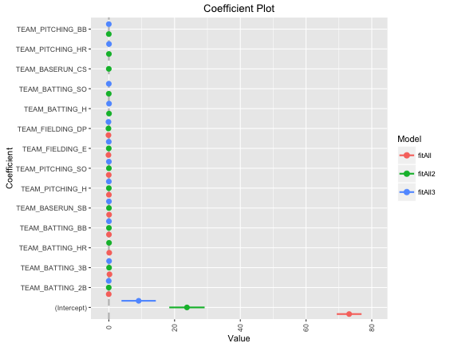

***Summary***

After comparing the three models, I would use the first. Although there is room for improvement in goodness-of-fit measures, the p-value (<2.2e-16) and f-statistic (104.6 on 11 variables and 1474 degrees of freedom) indicate that the model is statistically significant. The residuals for the fit are normally distributed around a mean of zero. I used the first model to predict the number of wins for the records in the evaluation set. Our predictions, with wins rounded to the nearest whole number, along with their prediction and confidence intervals are included in the appendix.

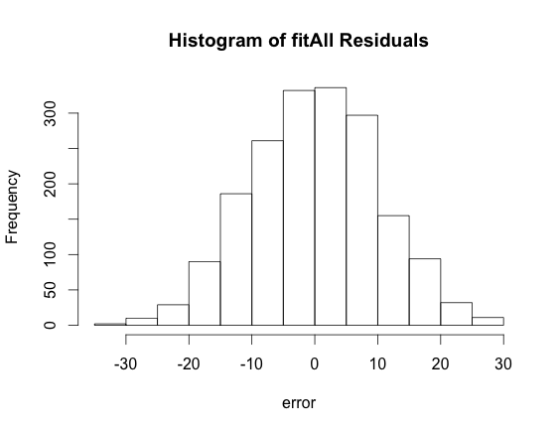

***Appendix***

|  |  |  |  |  |  |  |  |  |  |  |  |  |  |  |  |  |  |
| --- | --- | --- | --- | --- | --- | --- | --- | --- | --- | --- | --- | --- | --- | --- | --- | --- | --- |
| ***index*** | ***fit*** | ***c-l*** | ***c-u*** | ***p-l*** | ***p-u*** | ***in.*** | ***fit*** | ***c-l*** | ***c-u*** | ***p-l*** | ***p-u*** | ***in.*** | ***fit*** | ***c-l*** | ***c-u*** | ***p-l*** | ***p-u*** |
| ***1*** | 61 | 59 | 62 | 41 | 81 | ***43*** | 74 | 73 | 75 | 54 | 94 | ***85*** | 72 | 71 | 74 | 52 | 92 |
| ***2*** | 67 | 65 | 68 | 47 | 87 | ***44*** | 75 | 74 | 77 | 55 | 96 | ***86*** | 89 | 88 | 90 | 69 | 109 |
| ***3*** | 71 | 70 | 72 | 51 | 91 | ***45*** | 69 | 68 | 70 | 49 | 89 | ***87*** | 91 | 90 | 92 | 71 | 111 |
| ***4*** | 84 | 83 | 85 | 64 | 104 | ***46*** | 78 | 77 | 79 | 58 | 98 | ***88*** | 91 | 89 | 93 | 71 | 111 |
| ***5*** | 64 | 62 | 66 | 44 | 84 | ***47*** | 92 | 89 | 95 | 72 | 112 | ***89*** | 95 | 93 | 96 | 75 | 115 |
| ***6*** | 73 | 72 | 75 | 53 | 94 | ***48*** | 77 | 75 | 79 | 57 | 97 | ***90*** | 91 | 89 | 92 | 70 | 111 |
| ***7*** | 70 | 69 | 72 | 50 | 91 | ***49*** | 92 | 90 | 93 | 72 | 112 | ***91*** | 79 | 78 | 80 | 59 | 99 |
| ***8*** | 63 | 62 | 65 | 43 | 83 | ***50*** | 83 | 81 | 85 | 63 | 103 | ***92*** | 76 | 75 | 77 | 56 | 96 |
| ***9*** | 84 | 83 | 85 | 64 | 104 | ***51*** | 87 | 86 | 88 | 67 | 107 | ***93*** | 84 | 83 | 85 | 64 | 104 |
| ***10*** | 87 | 85 | 88 | 67 | 107 | ***52*** | 85 | 83 | 86 | 65 | 105 | ***94*** | 83 | 82 | 84 | 63 | 103 |
| ***11*** | 83 | 81 | 84 | 63 | 103 | ***53*** | 85 | 84 | 87 | 65 | 105 | ***95*** | 67 | 66 | 69 | 47 | 87 |
| ***12*** | 87 | 86 | 89 | 67 | 108 | ***54*** | 58 | 55 | 60 | 37 | 78 | ***96*** | 70 | 68 | 71 | 50 | 90 |
| ***13*** | 76 | 74 | 77 | 56 | 96 | ***55*** | 64 | 62 | 66 | 44 | 84 | ***97*** | 83 | 81 | 85 | 63 | 103 |
| ***14*** | 71 | 70 | 72 | 51 | 91 | ***56*** | 93 | 90 | 95 | 72 | 113 | ***98*** | 84 | 83 | 86 | 64 | 105 |
| ***15*** | 76 | 75 | 77 | 56 | 96 | ***57*** | 90 | 88 | 93 | 70 | 110 | ***99*** | 76 | 74 | 77 | 56 | 96 |
| ***16*** | 87 | 85 | 88 | 66 | 107 | ***58*** | 73 | 71 | 74 | 52 | 93 | ***100*** | 92 | 90 | 93 | 71 | 112 |
| ***17*** | 85 | 84 | 87 | 65 | 106 | ***59*** | 82 | 81 | 84 | 62 | 102 | ***101*** | 87 | 86 | 89 | 67 | 107 |
| ***18*** | 82 | 80 | 83 | 62 | 102 | ***60*** | 94 | 92 | 96 | 74 | 114 | ***102*** | 80 | 79 | 81 | 60 | 100 |
| ***19*** | 84 | 82 | 85 | 64 | 104 | ***61*** | 69 | 67 | 70 | 48 | 89 | ***103*** | 81 | 80 | 83 | 61 | 102 |
| ***20*** | 71 | 69 | 72 | 50 | 91 | ***62*** | 77 | 75 | 78 | 56 | 97 | ***104*** | 74 | 73 | 75 | 54 | 94 |
| ***21*** | 78 | 77 | 79 | 58 | 98 | ***63*** | 89 | 88 | 90 | 69 | 109 | ***105*** | 80 | 79 | 82 | 60 | 101 |
| ***22*** | 84 | 83 | 86 | 64 | 105 | ***64*** | 82 | 81 | 83 | 62 | 102 | ***106*** | 91 | 90 | 92 | 71 | 111 |
| ***23*** | 67 | 66 | 69 | 47 | 88 | ***65*** | 81 | 79 | 82 | 60 | 101 | ***107*** | 78 | 77 | 79 | 58 | 98 |
| ***24*** | 81 | 79 | 83 | 61 | 101 | ***66*** | 84 | 82 | 85 | 64 | 104 | ***108*** | 75 | 74 | 76 | 55 | 95 |
| ***25*** | 63 | 61 | 65 | 43 | 84 | ***67*** | 93 | 91 | 94 | 72 | 113 | ***109*** | 93 | 91 | 96 | 73 | 114 |
| ***26*** | 92 | 90 | 93 | 72 | 112 | ***68*** | 71 | 69 | 72 | 51 | 91 | ***110*** | 80 | 80 | 81 | 60 | 100 |
| ***27*** | 89 | 88 | 90 | 69 | 109 | ***69*** | 88 | 86 | 89 | 67 | 108 | ***111*** | 51 | 49 | 53 | 31 | 71 |
| ***28*** | 85 | 84 | 87 | 65 | 105 | ***70*** | 79 | 78 | 81 | 59 | 100 | ***112*** | 92 | 91 | 94 | 72 | 112 |
| ***29*** | 84 | 82 | 86 | 64 | 104 | ***71*** | 86 | 85 | 88 | 66 | 106 | ***113*** | 68 | 66 | 69 | 48 | 88 |
| ***30*** | 80 | 78 | 81 | 59 | 100 | ***72*** | 85 | 84 | 86 | 65 | 105 | ***114*** | 76 | 75 | 77 | 56 | 96 |
| ***31*** | 86 | 84 | 87 | 66 | 106 | ***73*** | 96 | 94 | 98 | 76 | 116 | ***115*** | 74 | 73 | 75 | 54 | 94 |
| ***32*** | 77 | 76 | 77 | 57 | 97 | ***74*** | 91 | 89 | 92 | 70 | 111 | ***116*** | 75 | 74 | 76 | 55 | 95 |
| ***33*** | 91 | 89 | 92 | 71 | 111 | ***75*** | 65 | 63 | 68 | 45 | 86 | ***117*** | 81 | 80 | 82 | 61 | 101 |
| ***34*** | 82 | 79 | 85 | 62 | 102 | ***76*** | 96 | 94 | 98 | 76 | 116 | ***118*** | 78 | 76 | 79 | 58 | 98 |
| ***35*** | 87 | 86 | 88 | 67 | 107 | ***77*** | 99 | 97 | 101 | 79 | 119 | ***119*** | 84 | 83 | 85 | 64 | 104 |
| ***36*** | 81 | 79 | 82 | 61 | 101 | ***78*** | 88 | 86 | 89 | 68 | 108 | ***120*** | 83 | 82 | 84 | 63 | 103 |
| ***37*** | 92 | 91 | 94 | 72 | 112 | ***79*** | 91 | 89 | 93 | 71 | 111 | ***121*** | 78 | 77 | 79 | 58 | 98 |
| ***38*** | 73 | 71 | 74 | 53 | 93 | ***80*** | 78 | 77 | 80 | 58 | 98 | ***122*** | 61 | 59 | 62 | 41 | 81 |
| ***39*** | 65 | 63 | 66 | 45 | 85 | ***81*** | 73 | 72 | 74 | 53 | 93 | ***123*** | 77 | 76 | 78 | 57 | 97 |
| ***40*** | 79 | 78 | 80 | 59 | 99 | ***82*** | 82 | 81 | 83 | 62 | 102 | ***124*** | 68 | 67 | 70 | 48 | 89 |
| ***41*** | 74 | 72 | 75 | 54 | 94 | ***83*** | 87 | 86 | 89 | 67 | 108 | ***125*** | 92 | 90 | 93 | 72 | 112 |
| ***42*** | 81 | 80 | 83 | 61 | 101 | ***84*** | 74 | 72 | 75 | 54 | 94 | ***126*** | 81 | 77 | 84 | 60 | 101 |

|  |  |  |  |  |  |  |  |  |  |  |  |
| --- | --- | --- | --- | --- | --- | --- | --- | --- | --- | --- | --- |
| ***in.*** | ***fit*** | ***c-l*** | ***c-u*** | ***p-l*** | ***p-u*** | ***in.*** | ***fit*** | ***c-l*** | ***c-u*** | ***p-l*** | ***p-u*** |
| ***127*** | 106 | 104 | 109 | 86 | 127 | ***169*** | 81 | 80 | 82 | 61 | 101 |
| ***128*** | 114 | 112 | 116 | 94 | 134 | ***170*** | 78 | 76 | 80 | 58 | 98 |
| ***129*** | 100 | 98 | 102 | 80 | 120 | ***171*** | 96 | 94 | 98 | 76 | 116 |
| ***130*** | 108 | 106 | 110 | 88 | 128 | ***172*** | 75 | 74 | 76 | 55 | 95 |
| ***131*** | 103 | 101 | 105 | 83 | 123 | ***173*** | 82 | 81 | 83 | 62 | 102 |
| ***132*** | 100 | 98 | 101 | 79 | 120 | ***174*** | 72 | 70 | 73 | 51 | 92 |
| ***133*** | 87 | 85 | 88 | 67 | 107 | ***175*** | 69 | 68 | 71 | 49 | 89 |
| ***134*** | 86 | 85 | 88 | 66 | 107 | ***176*** | 77 | 75 | 78 | 56 | 97 |
| ***135*** | 72 | 71 | 73 | 52 | 92 | ***177*** | 69 | 67 | 71 | 49 | 89 |
| ***136*** | 79 | 78 | 80 | 59 | 99 | ***178*** | 81 | 80 | 82 | 61 | 101 |
| ***137*** | 93 | 92 | 95 | 73 | 113 | ***179*** | 78 | 77 | 79 | 58 | 98 |
| ***138*** | 83 | 82 | 84 | 63 | 103 | ***180*** | 78 | 76 | 79 | 57 | 98 |
| ***139*** | 93 | 91 | 94 | 73 | 113 | ***181*** | 84 | 83 | 85 | 64 | 104 |
| ***140*** | 79 | 77 | 80 | 58 | 99 | ***182*** | 96 | 95 | 98 | 76 | 117 |
| ***141*** | 79 | 77 | 80 | 59 | 99 | ***183*** | 86 | 85 | 87 | 66 | 106 |
| ***142*** | 84 | 83 | 86 | 64 | 105 | ***184*** | 88 | 87 | 89 | 68 | 108 |
| ***143*** | 69 | 67 | 70 | 48 | 89 | ***185*** | 80 | 79 | 80 | 60 | 100 |
| ***144*** | 74 | 73 | 75 | 54 | 94 | ***186*** | 76 | 75 | 77 | 56 | 96 |
| ***145*** | 81 | 80 | 82 | 61 | 101 | ***187*** | 75 | 74 | 76 | 55 | 95 |
| ***146*** | 100 | 97 | 103 | 80 | 120 | ***188*** | 81 | 80 | 83 | 61 | 102 |
| ***147*** | 90 | 88 | 91 | 70 | 110 | ***189*** | 72 | 70 | 73 | 52 | 92 |
| ***148*** | 87 | 86 | 88 | 67 | 107 | ***190*** | 87 | 86 | 88 | 67 | 107 |
| ***149*** | 86 | 85 | 87 | 66 | 106 | ***191*** | 90 | 89 | 92 | 70 | 110 |
| ***150*** | 67 | 66 | 69 | 47 | 88 | ***192*** | 82 | 81 | 83 | 62 | 102 |
| ***151*** | 70 | 68 | 71 | 50 | 90 | ***193*** | 79 | 78 | 80 | 59 | 99 |
| ***152*** | 66 | 64 | 68 | 46 | 86 | ***194*** | 60 | 59 | 62 | 40 | 81 |
| ***153*** | 61 | 59 | 63 | 41 | 81 | ***195*** | 82 | 80 | 84 | 62 | 102 |
| ***154*** | 72 | 71 | 73 | 52 | 92 | ***196*** | 76 | 75 | 78 | 56 | 97 |
| ***155*** | 95 | 93 | 97 | 75 | 115 | ***197*** | 84 | 83 | 85 | 64 | 104 |
| ***156*** | 85 | 84 | 86 | 65 | 105 | ***198*** | 74 | 73 | 75 | 54 | 94 |
| ***157*** | 84 | 83 | 85 | 64 | 104 | ***199*** | 84 | 83 | 86 | 64 | 104 |
| ***158*** | 72 | 70 | 73 | 52 | 92 | ***200*** | 78 | 77 | 80 | 58 | 99 |
| ***159*** | 79 | 78 | 80 | 59 | 99 | ***201*** | 70 | 69 | 72 | 50 | 90 |
| ***160*** | 76 | 75 | 78 | 56 | 96 | ***202*** | 80 | 78 | 81 | 60 | 100 |
| ***161*** | 96 | 93 | 99 | 76 | 116 | ***203*** | 83 | 82 | 85 | 63 | 104 |
| ***162*** | 81 | 80 | 82 | 61 | 101 | ***204*** | 86 | 85 | 88 | 66 | 106 |
| ***163*** | 89 | 88 | 90 | 69 | 109 | ***205*** | 71 | 69 | 73 | 51 | 91 |
| ***164*** | 74 | 73 | 76 | 54 | 94 |  |  |  |  |  |  |
| ***165*** | 76 | 75 | 78 | 56 | 96 |  |  |  |  |  |  |
| ***166*** | 88 | 86 | 90 | 68 | 108 |  |  |  |  |  |  |
| ***167*** | 64 | 62 | 65 | 44 | 84 |  |  |  |  |  |  |
| ***168*** | 70 | 69 | 72 | 50 | 90 |  |  |  |  |  |  |

*My data analysis was performed using R. The packages and code used for my plots and analysis can be found here:*

library(psych)

library(car)

library(coefplot)

training <- read.csv("moneyball-training-data.csv", header=T)

evaluation <- read.csv("moneyball-evaluation-data.csv", header=T)

training <- training[,-1] # remove index

# plot histograms of all variables

par(mfrow=c(2,4))

for (i in 1:8){

hist(training[,i], breaks=20, xlab=colnames(training)[i],main=NA)

}

par(mfrow=c(2,4))

for (i in 9:16){

hist(training[,i], breaks=20, xlab=colnames(training)[i],main=NA)

}

# summary stats

summary(training)

# pct of seasons with fewer than 60 losses or more than 102 wins

nrow(training[training$TARGET_WINS<60 | training$TARGET_WINS>102,])*100/nrow(training)

# examine strikeout outliers

subset(training,TEAM_PITCHING_SO>2500)

# delete from dataframe

training <- training[-c(1,282,1342,1826,2136),]

# fixed SO distribution

hist(training$TEAM_PITCHING_SO, breaks=20, main="Adjusted P_SO Distribution",xlab=NA)

# check for NA values and measure proportion

na_count <-sapply(training, function(y) sum(length(which(is.na(y)))))

na_pct <- na_count*100/nrow(training)

na_pct <- data.frame(na_pct)

na_pct

#next look at a correlation matrix

training <- training[,-10] # remove HBP

corrMatrix <- cor(training, use = "na.or.complete")

#pVal <- corr.test(corrMatrix,y=NULL)

#pVal <- data.frame(pVal)

roundedCM <- round(corrMatrix,2)

# Fit all predictors individually and plot error distributions

fitList <- list()

par(mfrow=c(2,4))

for(i in 2:15){

fitName <- colnames(training)[i]

fitList[[ fitName ]] <- lm(TARGET_WINS~training[,i],training)

}

par(mfrow=c(2,4))

for (i in 2:9){

hist(summary(fitList[[i]])$residuals,xlab="error",main=paste("WINS ~",names(fitList)[i-1]),breaks=20)

}

par(mfrow=c(1,5))

for (i in 10:14){

hist(summary(fitList[[i]])$residuals,xlab="error",main=paste("WINS ~",names(fitList)[i-1]),breaks=20)

}

# Repeat for square of residuals to check for homoscedasticity

par(mfrow=c(2,4))

for (i in 2:9){

plot(summary(fitList[[i]])$residuals^2,ylab="Residual Squared",main=paste("WINS ~",names(fitList)[i-1]))

}

par(mfrow=c(1,5))

for (i in 10:14){

plot(summary(fitList[[i]])$residuals^2,ylab="Residual Squared",main=paste("WINS ~",names(fitList)[i-1]))

}

# find best r-squared of single predictors

# high value is fitList[[1]]

for (i in 1:length(fitList)){

print(summary(fitList[[i]])$r.squared)

}

fitAll <- lm(TARGET_WINS ~., training)

fitAll <- update(fitAll, . ~ . -TEAM_PITCHING_BB) #R-squared 0.4386

fitAll <- update(fitAll, . ~ . -TEAM_PITCHING_HR) #R-squared 0.4386

fitAll <- update(fitAll, . ~ . -TEAM_BATTING_SO) #R-squared 0.4384

summary(fitAll)$r.squared

summary(fitAll)$coefficients

# impute missing values

tmeans <- apply(training, 2, mean, na.rm=T)

tmedian <- apply(training, 2, mean, na.rm=T)

trainingImputed <- training

for (i in c(9,13,15)){

for (j in 1:nrow(trainingImputed)){

if (is.na(trainingImputed[j,i])){

trainingImputed[j,i] <- tmeans[i]

}

}

}

for (i in c(7,8)){

for (j in 1:nrow(trainingImputed)){

if (is.na(trainingImputed[j,i])){

trainingImputed[j,i] <- tmedian[i]

}

}

}

# backwards selection, model 2

fitAll2 <- lm(TARGET_WINS ~., trainingImputed)

summary(fitAll2) #R-squared 0.3213, repeat for each

fitAll2 <- update(fitAll2, . ~ . -TEAM_PITCHING_HR) # R-squared 0.3212

fitAll2 <- update(fitAll2, . ~ . -TEAM_PITCHING_H) # R-squared 0.3211

fitAll2 <- update(fitAll2, . ~ . -TEAM_BASERUN_CS) # R-squared 0.3209

summary(fitAll2)$coefficients

# model 3

trainingImputed2 <- trainingImputed

for (i in 2:15){

for (j in 1:nrow(trainingImputed2)){

if (trainingImputed2[j,i]==0){

trainingImputed2[j,i] <- tmeans[i]

}

}

}

fitAll3 <- lm(TARGET_WINS ~., trainingImputed2) #R-squared 0.318

fitAll3 <- update(fitAll3, . ~ . -TEAM_BATTING_HR) #R-squared 0.318

fitAll3 <- update(fitAll3, . ~ . -TEAM_BASERUN_CS) #R-squared 0.318

# check variance inflations factors

vif(fitAll)

vif(fitAll2)

vif(fitAll3)

# BIC plot

full <- regsubsets(TARGET_WINS ~ ., training, nvmax = 15)

par(new=True)

plot(summary(full)$bic, xlab = "Number of Predictors", ylab = "BIC", type = "l",

main = "Best Subset Selection Using BIC")

# predict evaluation set, format table in excel

predict(fitAll,evaluation,na.action = na.exclude,interval = "confidence")

predict(fitAll,evaluation,na.action = na.exclude,interval = "prediction")

# compare coefficients for all models

multiplot(fitAll,fitAll2,fitAll3)

# plot of residuals for fitAll

hist(summary(fitAll)$residuals,xlab="error",main="Histogram of fitAll Residuals",breaks=20)